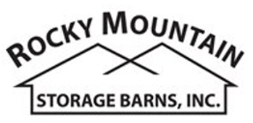

1201 E. Mulberry Street ● Fort Collins, CO 80524
Phone: (970)-221-0257 ● Fax (970) 472-5044
www.rmstoragebarns.com

12x16 Barn Grande Style Shed

Specifications
Windows | (3)-36"x23" Crank Out  (1) - 18" Octagon Window
Shingles | Architectural with  30yr Warranty
Shingle Color | Estate Grey
Siding Painted | Painted
Trim Paint | Painted
Extras | 5ft Ramp,  28' Workbench,  16' Ridge Vent
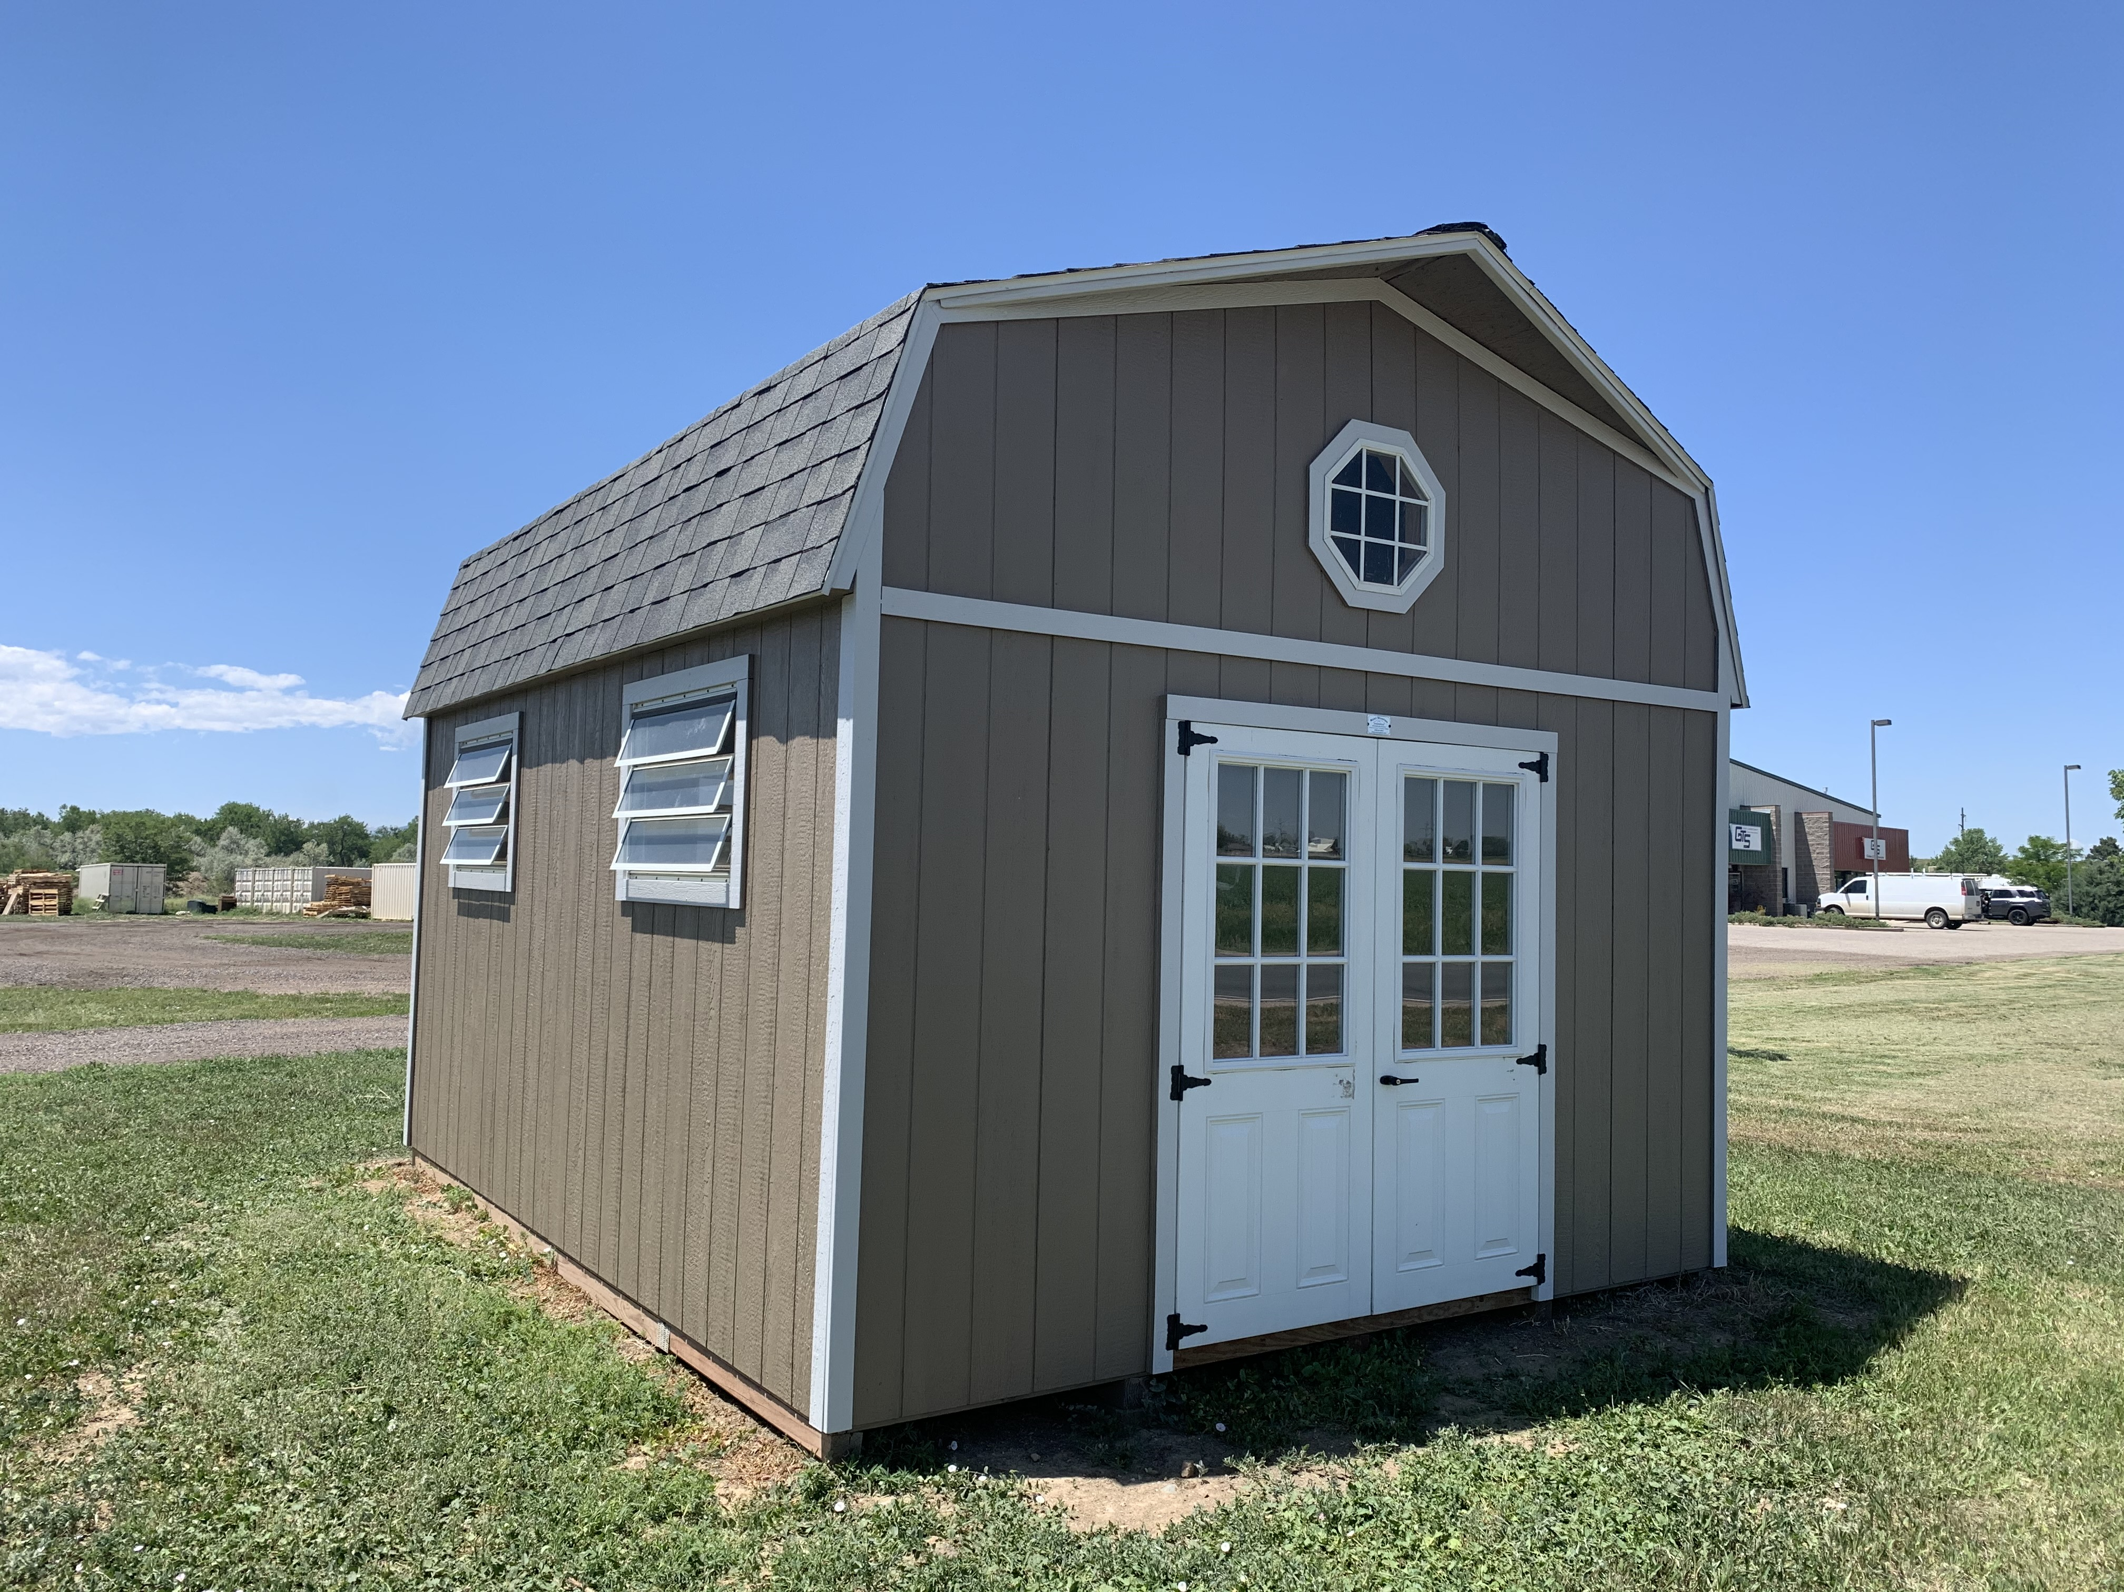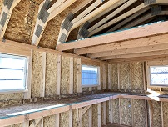
Specifications
Size | 12x16
Floor Material | Wood Floor  3/4" Tongue & Groove
Wall Height | 6'6" Studs @ 16" OC
Wall Material | T-1-11 Smartside with Vertical Grooves @ 8" OC
Door Size | 60.5x72 Fiberglass Double  Door w/ 9 Light
Door Material | Fiberglass
Loft | 4 ft Loft
Roof Style | Gambrel
Overhang | 16" on front

Pricing
Buy it Now | $7,091
Rent to Own  5yr Monthly | $283

(Sales tax & freight may be applicable)

