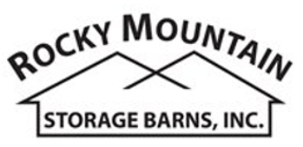

1201 E. Mulberry Street ● Fort Collins, CO 80524
Phone: (970)-221-0257 ● Fax (970) 472-5044
www.rmstoragebarns.com

8x10 Barn Style Shed

Specifications
Windows | 18"x23" Crank-out Window
Shingles | 30 Yr. Shingles: Driftwood
Siding Color | Green
Trim Color | White
Cupola | White Vinyl-Black Roof
Weathervane | Black Horse
Workbench | 2'x8' Workbench
Specifications
Size | 8x10'
Floor Material | Durstand 3/4" Tongue & Groove
Wall Height | 4' Studs @ 16" OC
Wall Material | T-1-11 Smartside with Vertical Grooves @ 8" OC
Door Size | 4' Wood Double Door
Overhang | 16" on front
Ramp | 4' Aluminum Ramp

Pricing
Buy it Now | $ 4,964
Rent to Own  5yr Monthly | $196

(Sales tax & freight may be applicable)

